Human Relations 3140 – 5140 – 90 – 91
Summer Sculpture!
Tim Lhotka
I wanted to incorporate my passion and interest of science fiction into my piece and make it personal in that way. So, I was inspired by my early memories of watching Star Trek and Star Wars with my parents. The message of togetherness and unity triumphing over oppression and hatred. Star Trek specifically did give me, later in life more than earlier in my case, a perspective that all humans are equal, no matter their nationality, ethnicity, cultural background, or orientation. They were all crewmates who worked together, respected each other even when they disagreed (most famously spock and bones!) and they got their job done. GENE RODDENBURY WAS A GENIUS WITH HIS THEMEAND THE UNIVERSAL APPEAL WAS VERY ENCOURAGING. WHAT HAPPENED????
Between that and the metaphorical inclusivity of Star Wars with the menagerie of aliens that were included in the Rebel Alliance and hated by the Galactic Empire, a similar concept to the mutants from X-Men for example. EXACTLY. REFLECT ON WHY THIS COMMON THEME IS REPEATED OVER AND OVER?
For this piece I used aliens to represent ‘people’ there are no humans in this piece because to some people, other humans do look alien or like monsters. HOW INSIGHTFUL In that way, we are all human yet nothing like but even so when we come together we can do great things. I chose the setting of an office space for two reasons: One, to give my characters a relatable place to come together to work and Two, to give each character their own unique space to represent how we all have interests and values that our outward appearance and attire do not necessarily show. AN A COMMON GOAL?
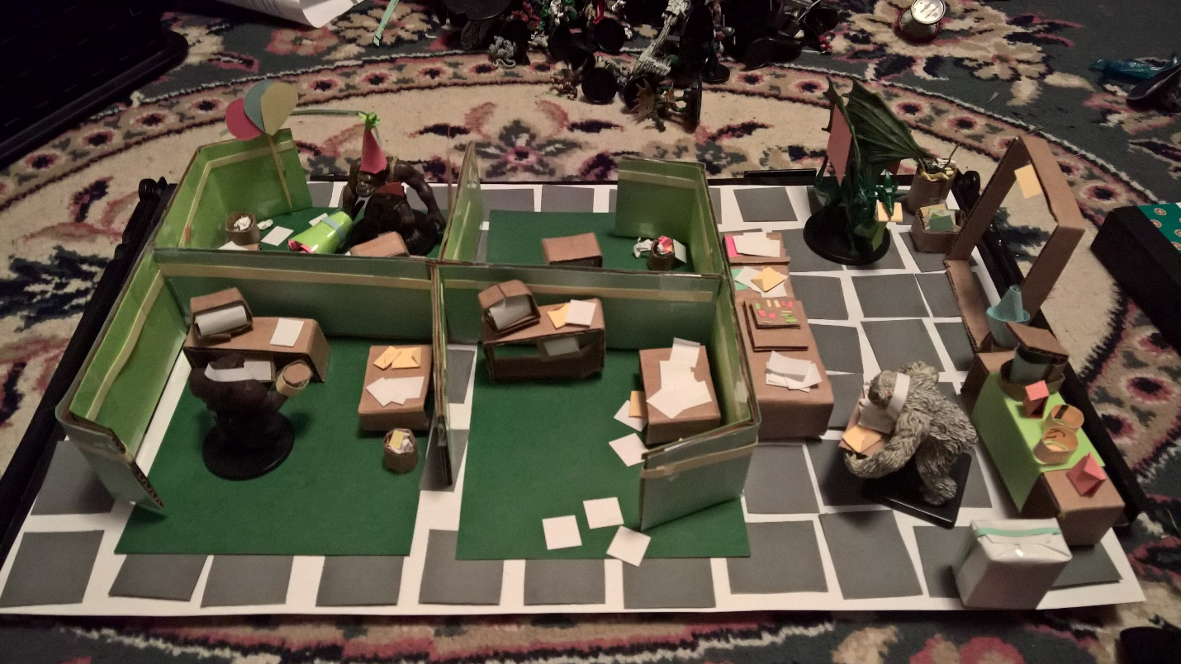
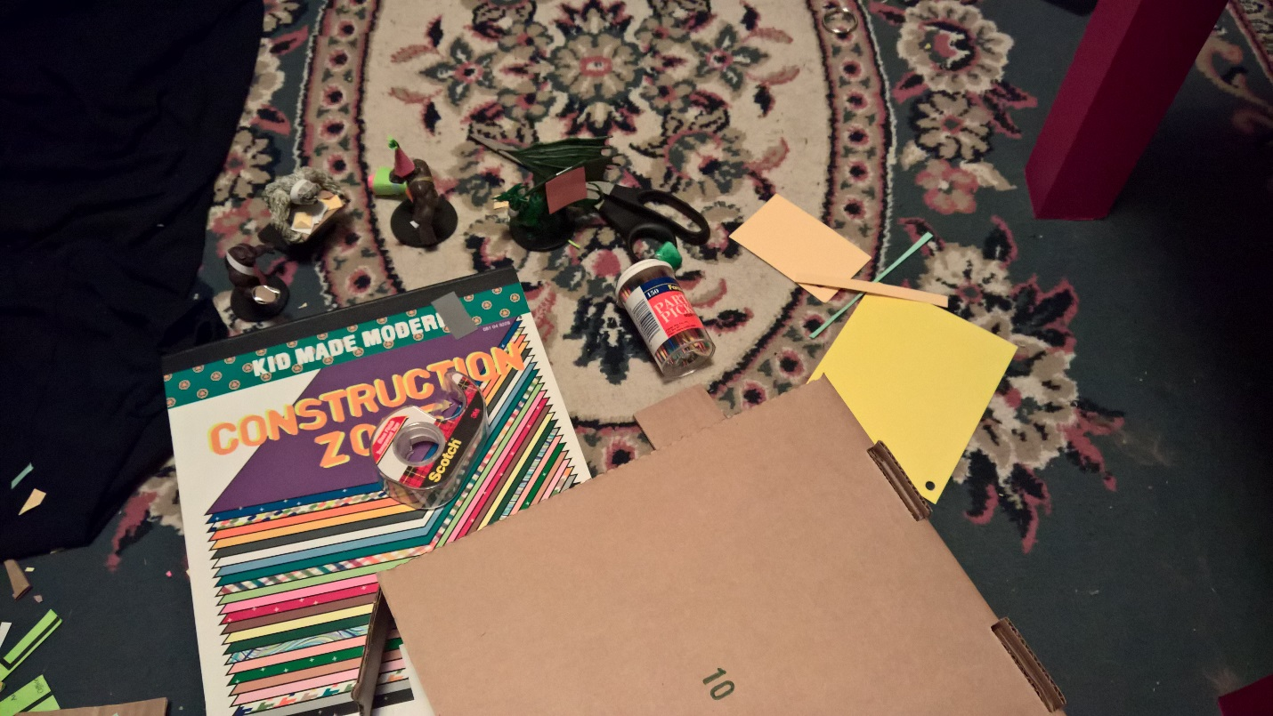
For my project, I will be using construction paper, cardboard, tape, toothpicks, a scissors to cut with, and some of my Star Wars Miniatures.
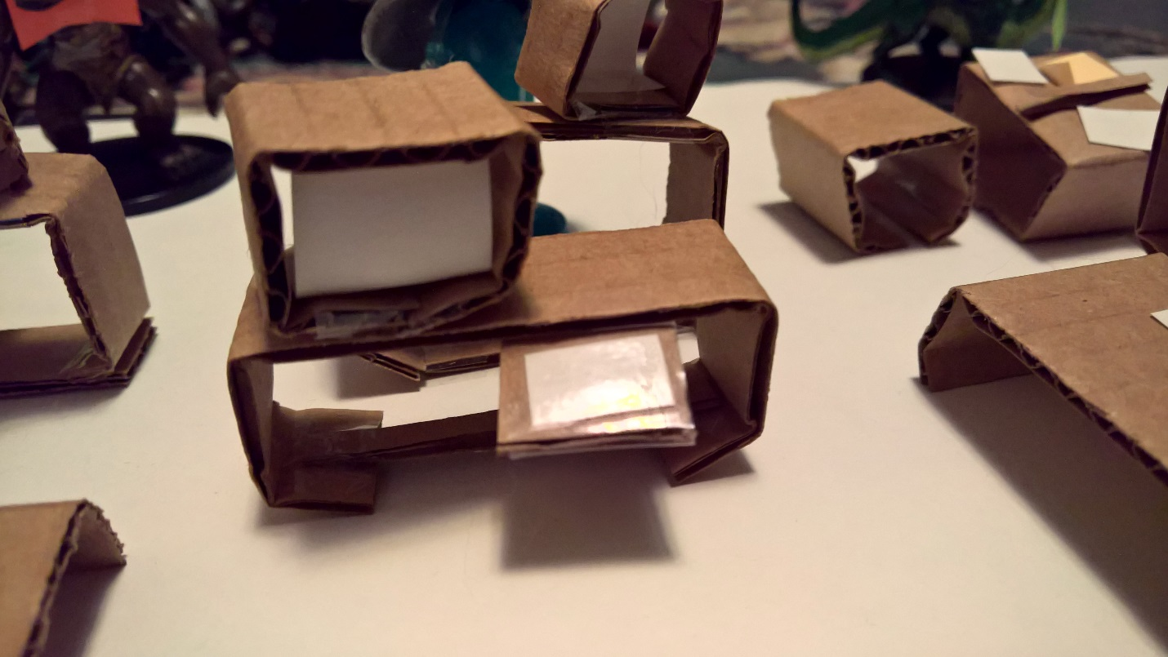
First up to make was the computers the office workers are going to use to do their jobs!

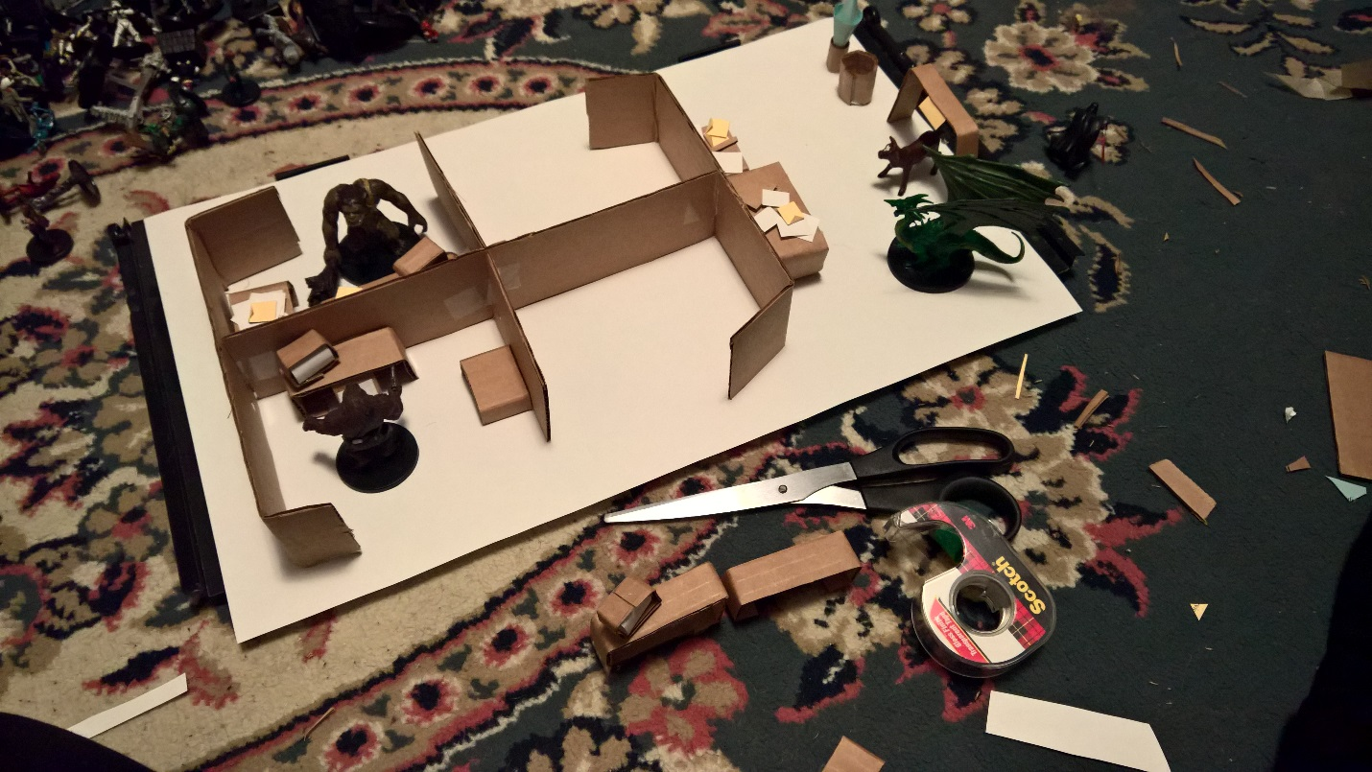
Early build during production. Planning stages!

Let’s introduce you to the office workers: 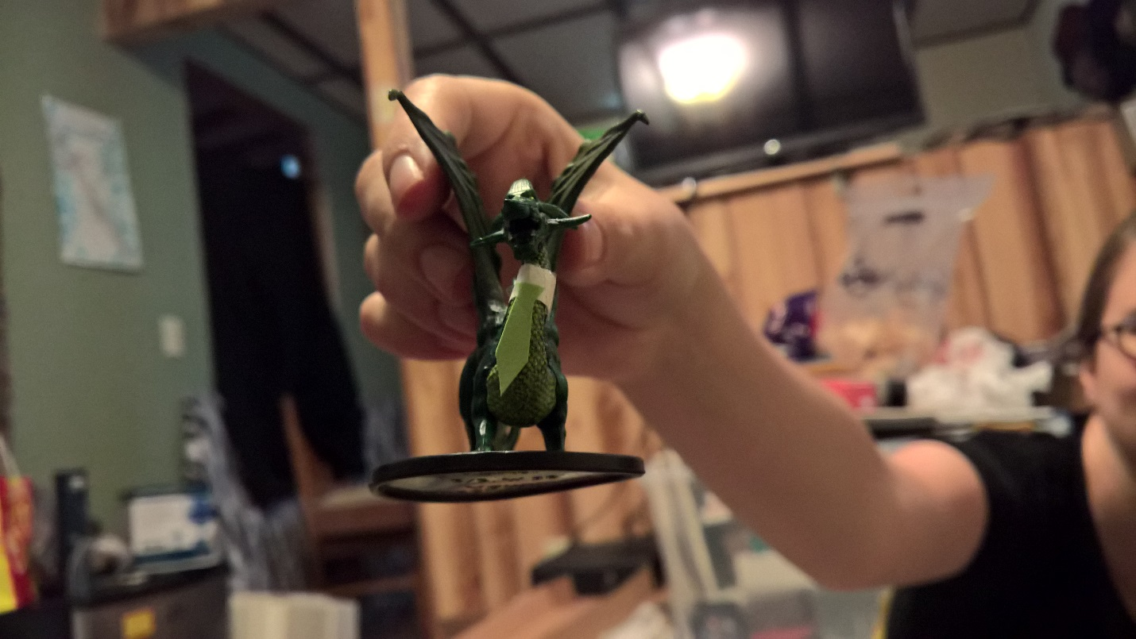

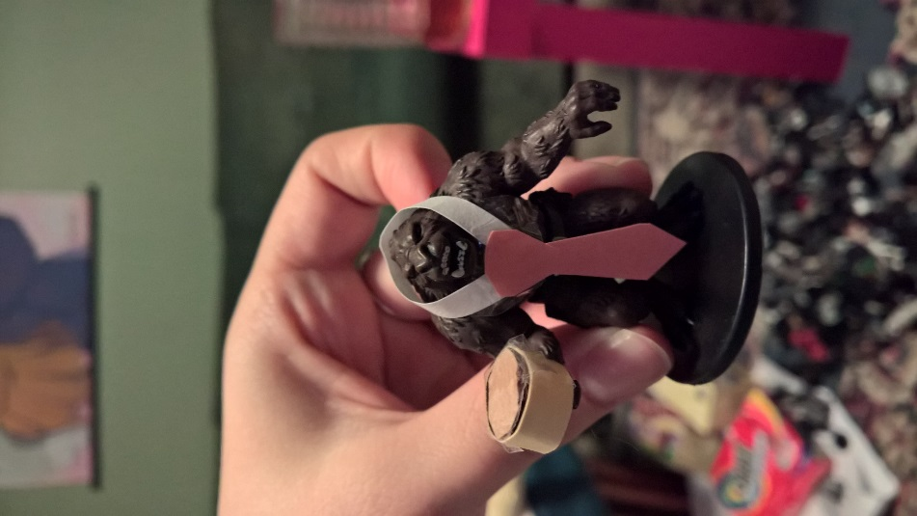
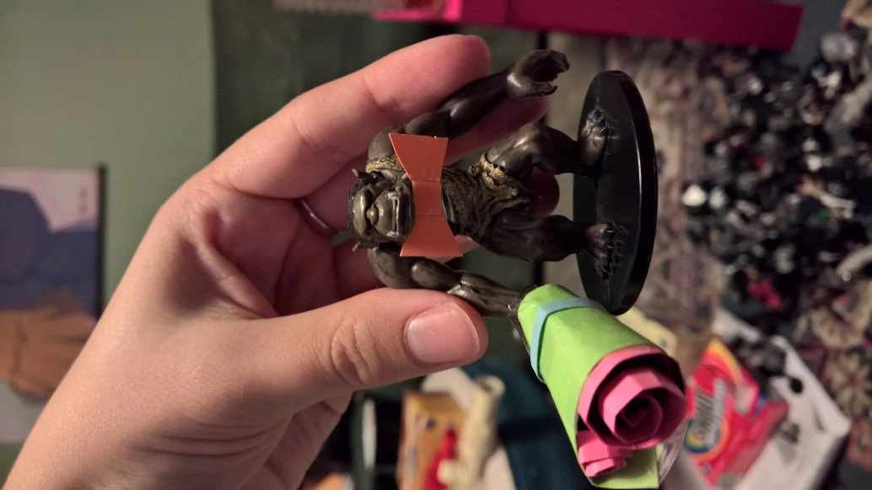
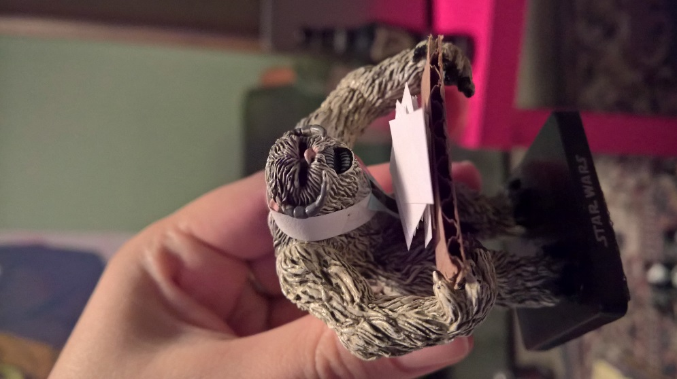

Every office needs a coffee machine!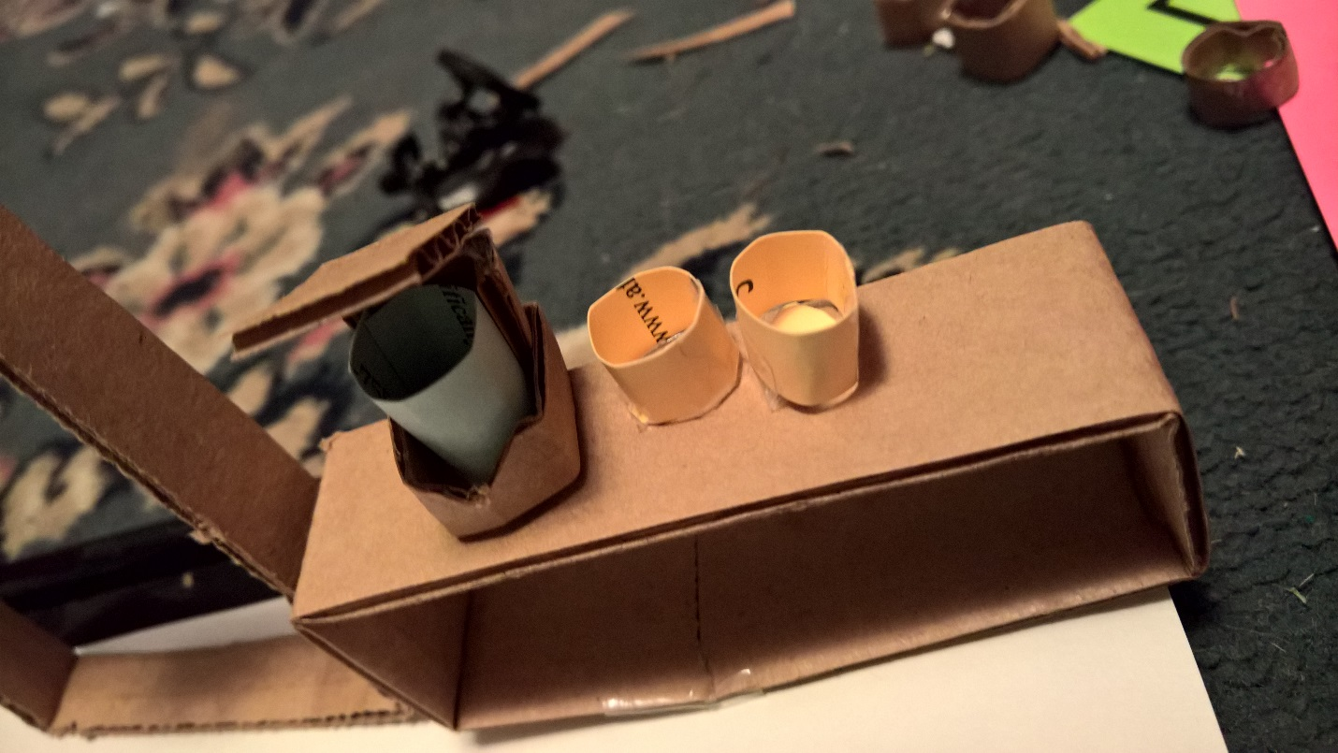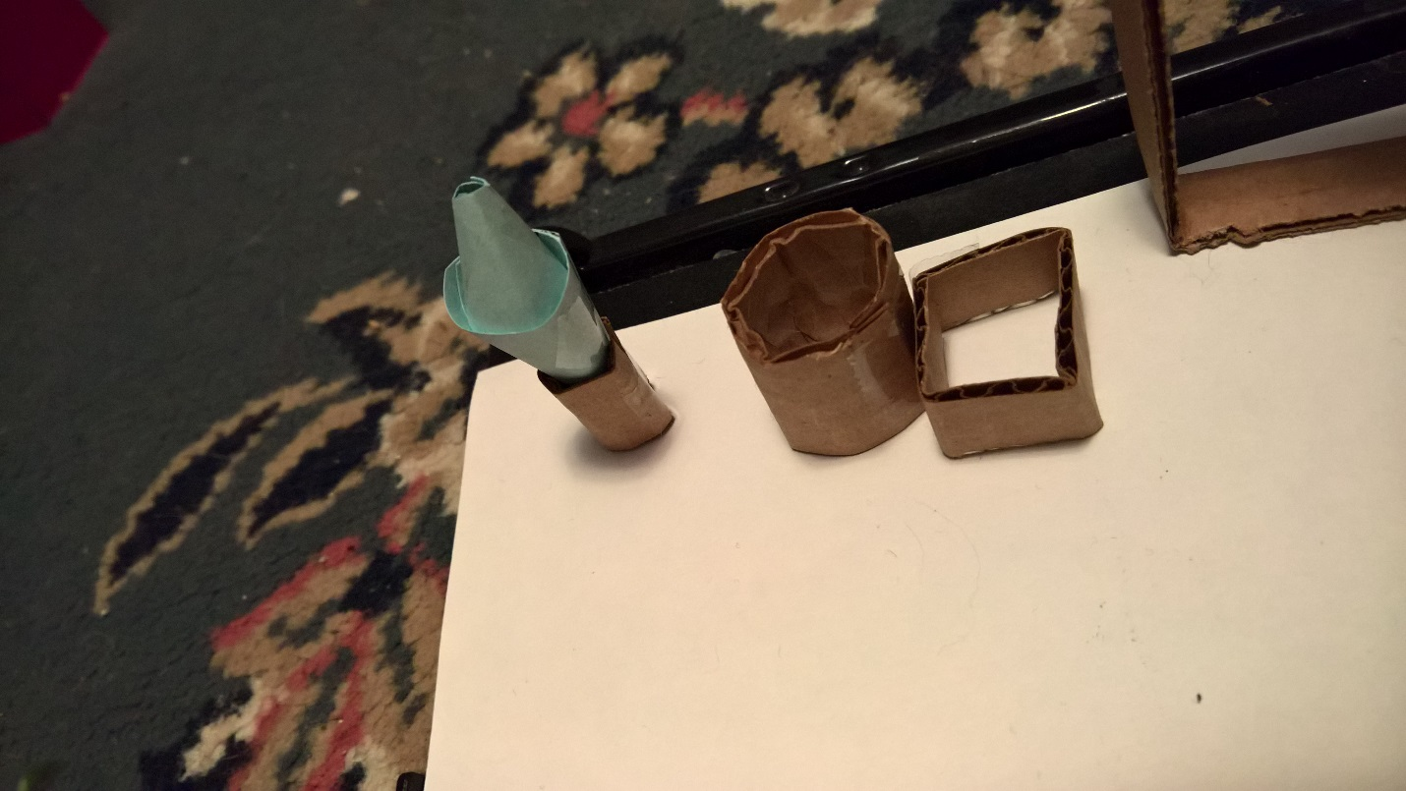
And a Water jug. The office is eco-friendly too with that square recycling bin!
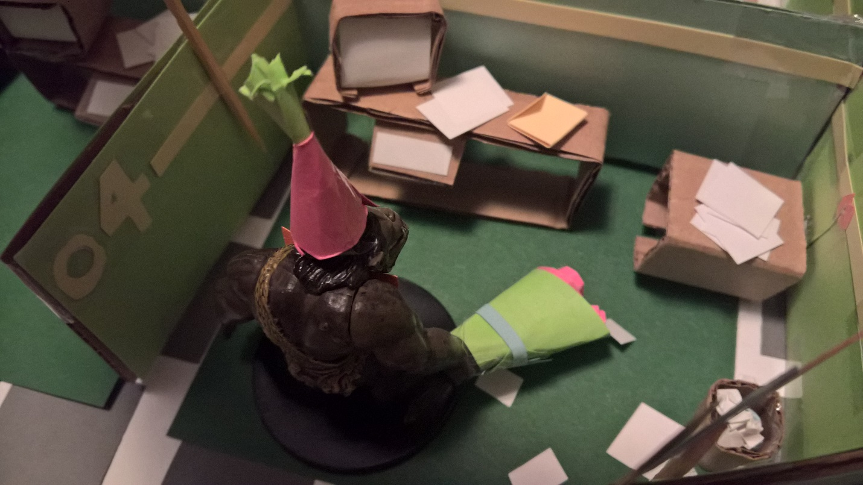
I lovingly dubbed this guy “Carl” it’s his Birthday today. WOW! THE DETAIL!!
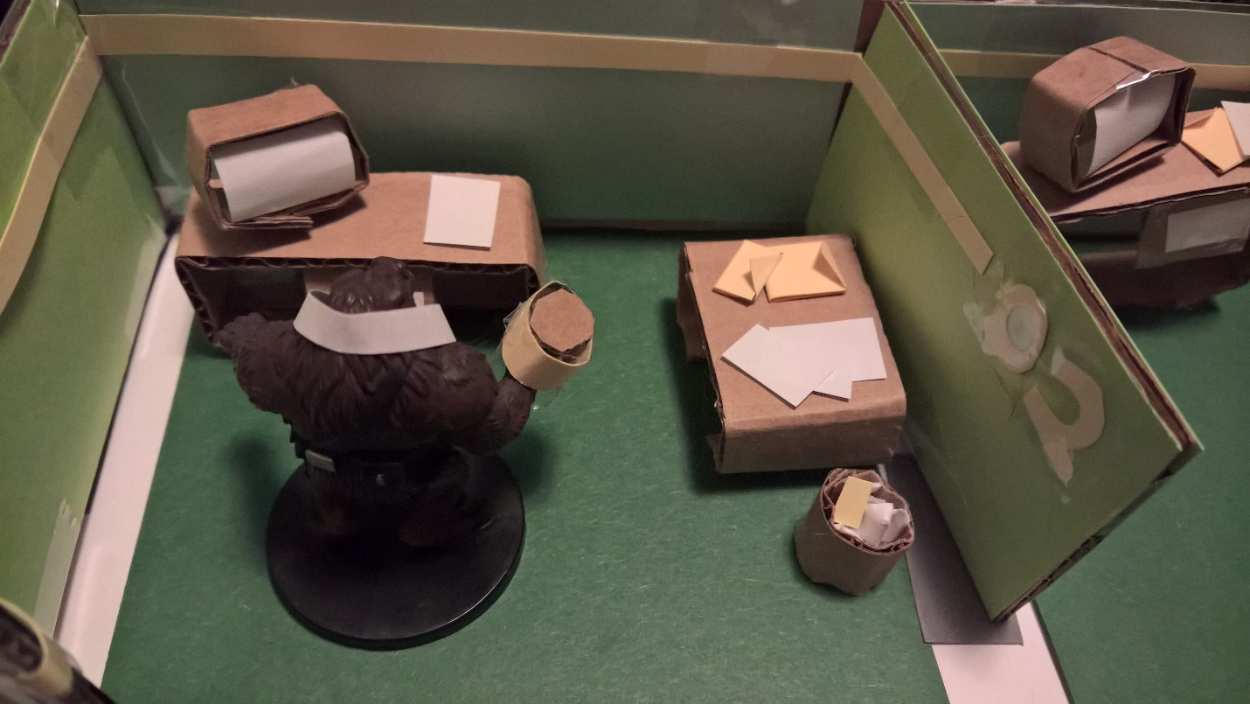
This is “Jeff” he is very neat and orderly, if you could not tell. (Especially compared to Carl!)
I started with a base of simple drawing paper. I put it on a wooden slab for extra support. From there I built the cubicles out from cardboard I got from an old pizza box! To add flavor and color to the project I put construction paper all around the walls and put a beige strip and numbers on the cubicles for trim. Each desk was individually made using cardboard as well, with the decorations of each cubicle representing an implications of the personality of each character (Carl’s cubicle is very disorganized with papers everywhere, for example.) Finally, I added additional props around such as the coffee maker and main door into the room.

