Playing Nice and the Danger of Divergent Discussion

In 1966, Linus said “There are three things I have learned never to discuss with people…Religion, Politics, and the Great Pumpkin.”

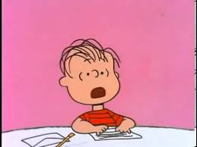

Is this sentiment still in effect today, in 2015?

- Have we been socially conditioned to avoid discussing topics that may reveal differences in thinking, beliefs, and/or philosophies? Is this interpreted as politeness? Are there disadvantages?
- Can and should we validate (empathizing, not necessarily agreeing with) differing perspectives? How can we accomplish this in our conversations? Are there exceptions?
- What are the elements of respectful discussion? Is political correctness “being nice” or unauthentic? Implications and disadvantages?

