Katherine Vinje
Bemidji State University
Human Relations 3140

White Privilege Summary

Summary:
White privilege is an unearned place in society that allows people who are born white to have an advantage in many aspects. Although some examples of white privilege are tangible such as products designed for lighter skin that are easy to access, others are not. Peggy McIntosh does a great job describing so many day-to-day experiences that someone who is white has and perhaps does not think a second about. For example, “6. When I am told about our national heritage or about civilization, I am shown that people of my color made it what it is” (McIntosh). Our curriculum is designed around the white man’s history and shows a very topical understanding of the many cultures and races that made the USA what it is today. We are doing a disservice to our students and to ourselves by leaving out their cultural heritage and giving superiority to the white race. The key is recognizing and understanding your own white privilege and being able to “be better quipped to see and understand systematic discrimination and inequality” (Dyer 2). As teachers we need to go beyond the curriculum; the standards and benchmarks and help students think outside the box.

Significant Idea

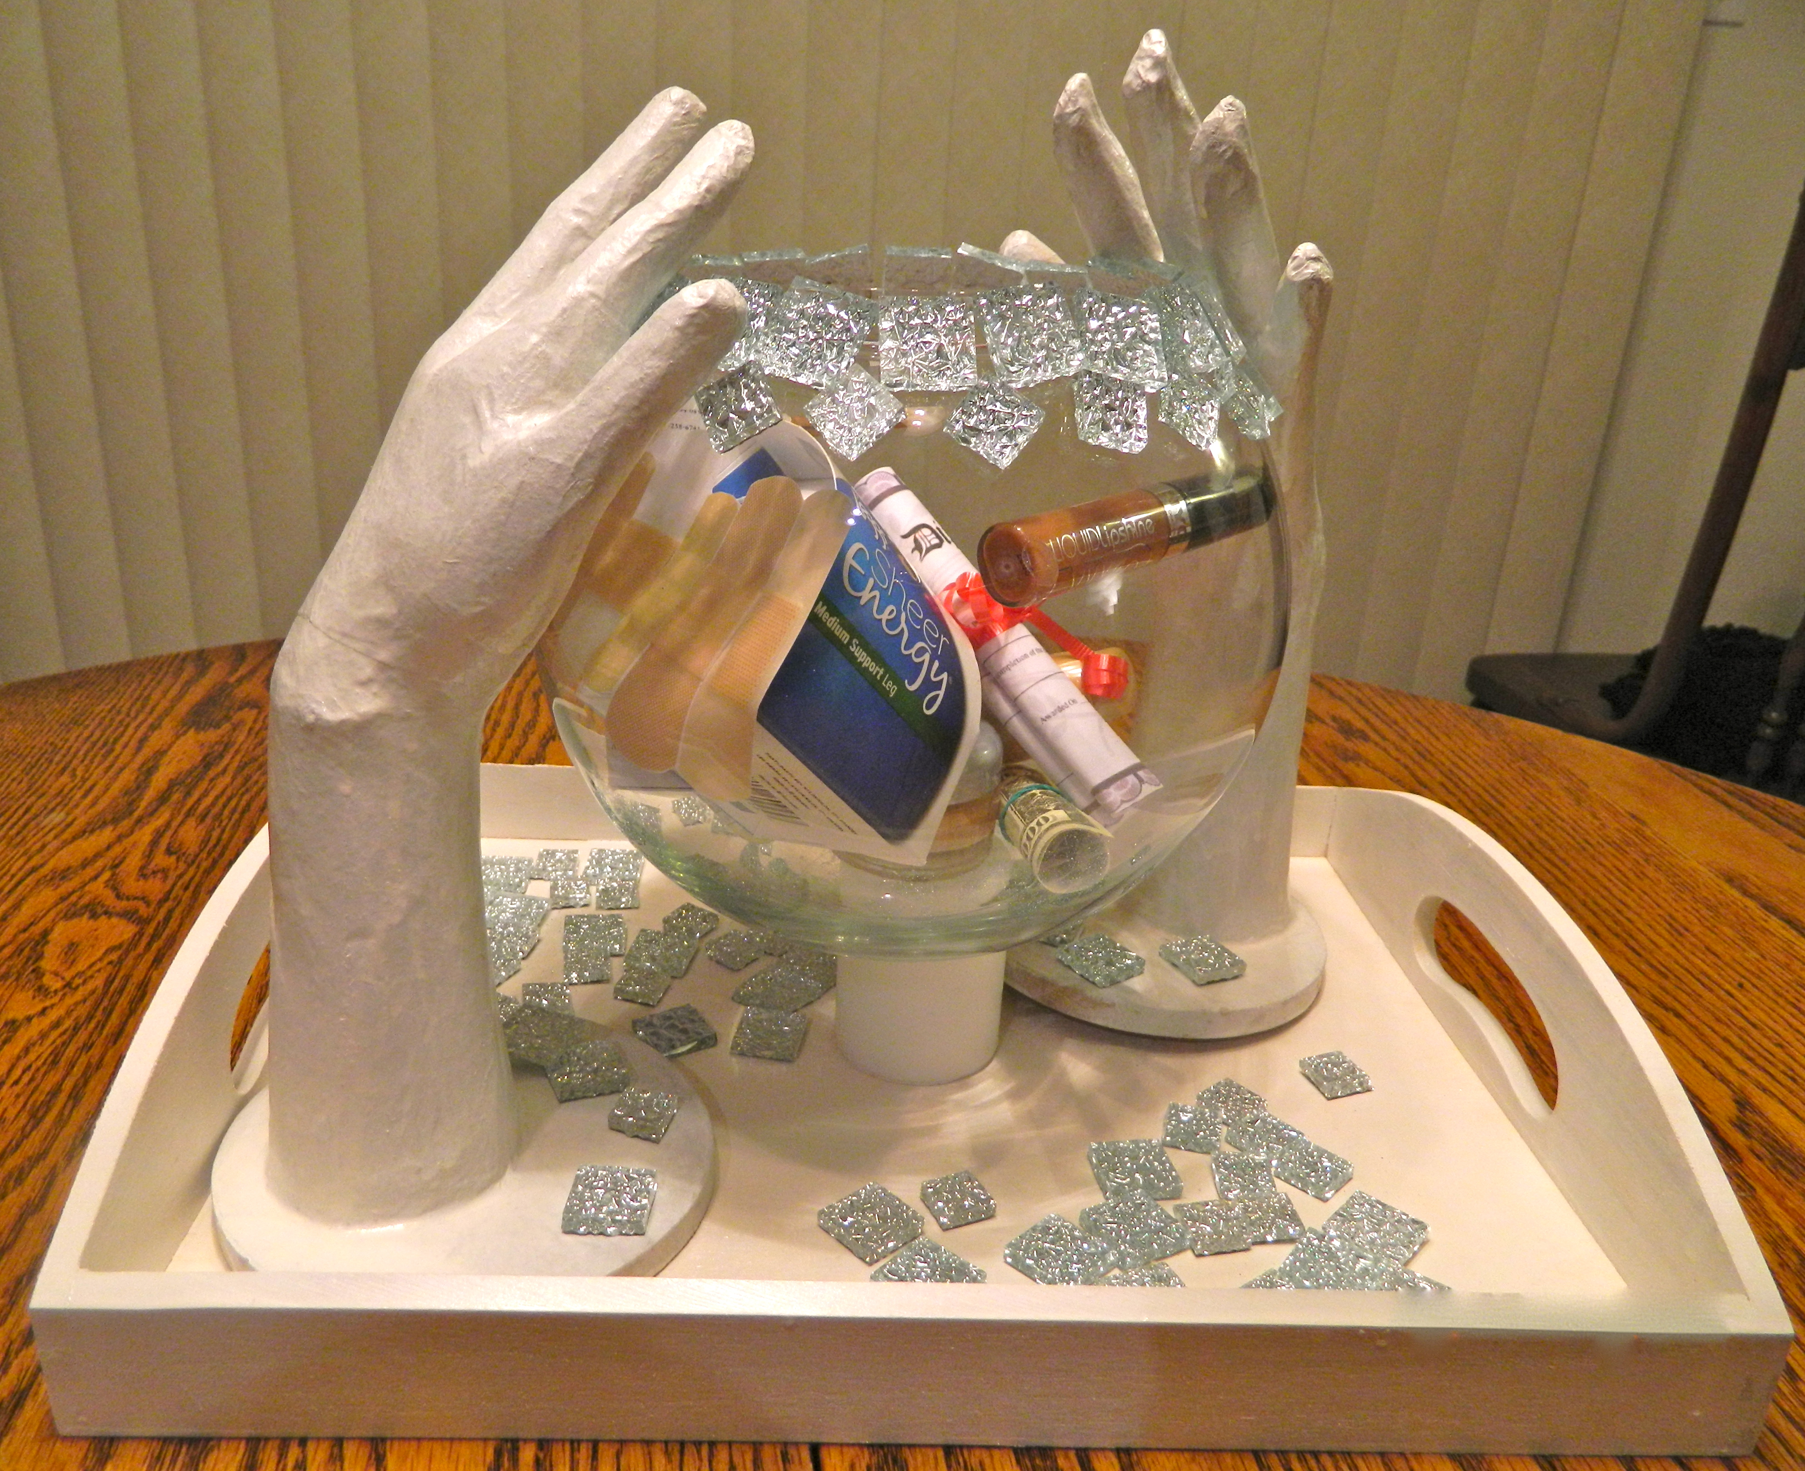
I decided to use my sculpture as the focal point of my lesson. I want the sculpture to be put to use and not sit in a corner. My concept was to create a bubble that has many of the tangible white privilege items. I included “flesh colored” band aids, gauze wraps, hotel shampoo that is offered to everyone who stays there yet only works for people with straight hair, nylons, and other products that are labeled nude or conveniently made for white people’s skin. There is also a university acceptance letter and a diploma in the bubble. I included white hands that support the bubble with some of the intangible white privilege concepts labeled on it. At some point, however, education can and does allow for that bubble to burst. A bubble that was at one time someone’s world where they were protected and shielded from the truth of the discriminatory history that we have in this country. I want the students to recognize their own white privilege, if white. If not, I believe this lesson will help support other students in knowing that I care about their history and present day struggles and that together we can work towards education and understanding inequalities.

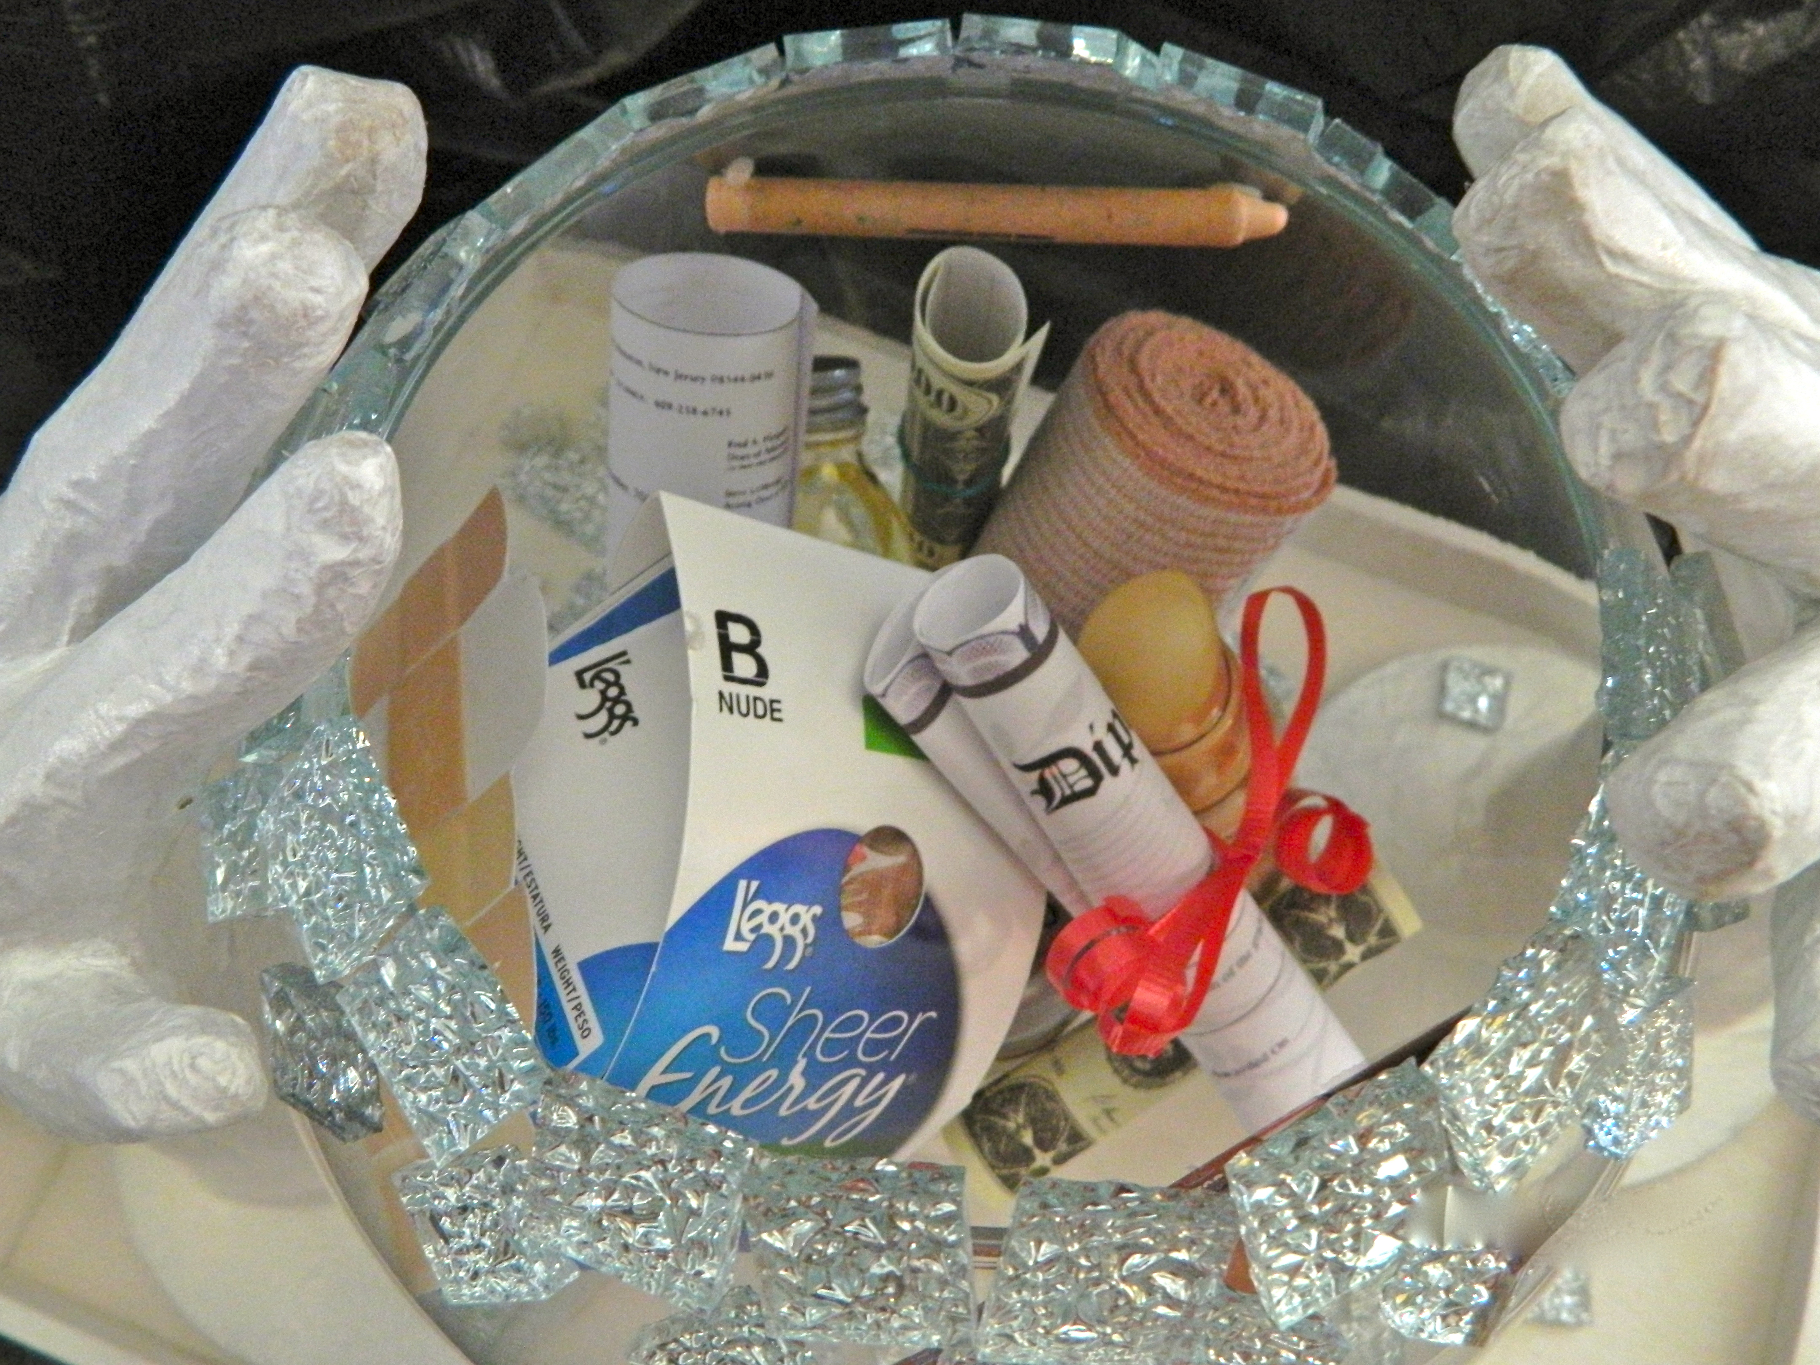

Lesson for grade 7-8
Time: 45-60 min.
Objective:
Students will be able to give examples of white privilege and explain why it is unearned.

Snappy Launch: Why does a bubble burst?

Procedure:
- Students will be asked to make a list of reasons different kinds of bubbles burst. The teacher will write them on the board. (Possible answers: outward objects puncture a bubble, too cold, too hot, weather conditions). Could this classroom become a bubble? Do we perhaps live in a bubble?
- Students will be presented with the sculpture and asked to write down what they observe. They will then be given a chance to approach the sculpture two-by-two and view it up close.
- The teacher will ask students to share what they think this sculpture is about.
- Students will watch a short YouTube clip entitled White Privilege http://www.youtube.com/watch?v=ysj_8fqnNcY
- The teacher will ask students once more what they think the sculpture is about.
- Students will be asked to get in small groups and make a list of other things that were stated in the video and ideas that come to mind that also are white privileges.
- The class will come together again and think about ways the inequalities can be addressed.
- Finally, students will be asked to write an essay on why white privilege in unearned and restate examples of white privilege.

Assessment:
4-Student explains the concept of unearned white privilege and gave examples beyond what was discussed in class.
3- Student explains the concept of unearned white privilege and gave examples.
2-Student explains the concept of white privilege but failed to give examples.
1-Student is unable to explain the concept of white privilege and is unable to complete the assignment.

Sources:

Dyer, Richard. White. London: Routledge, 1997. Print.

McIntosh, Peggy. "White Privilege: Unpacking the Invisible Knapsack." Independent School (1990): Print.

