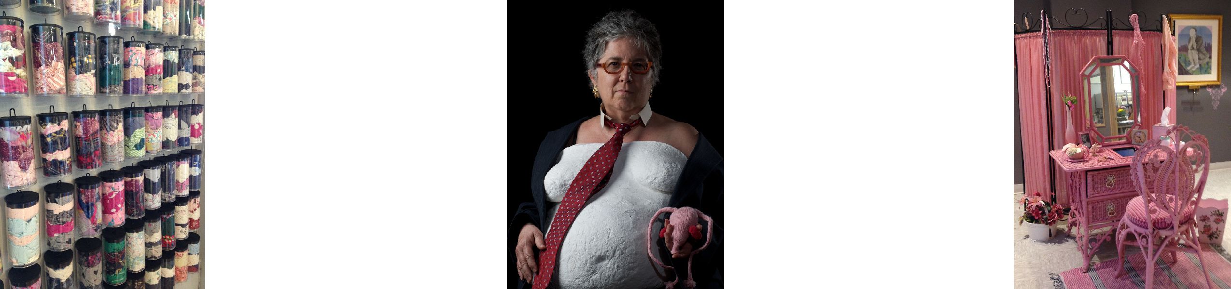

Susan Hensel • 3441 Cedar Ave S. • Minneapolis, MN 55407 • 612-722-2324
susanhensel@yahoo.com • www.susanhenselprojects.com

Susan Hensel
Bio

Susan Hensel received her BFA from University of Michigan in 1972 with a double major in painting and sculpture and a concentration in ceramics.

With a history, to date, of over 180 exhibitions, 25 of them solo, twenty garnering awards, Hensel's desire to communicate stories through art has had a broad effect.

Hensel's artwork is known and collected nationwide, represented in collecting libraries and museums as disparate as the Museum of Modern Art in New York and Duke University Special Collections with major holdings at Minnesota Center for Book Arts and University of Colorado at Boulder

In recent years Hensel has been awarded multiple grants and residencies through the Jerome Foundation, Minnesota State Arts Board, and Ragdale Foundation.

Hensel's curatorial work began in 2000 in East Lansing, Michigan with the Art Apartment and deepened with ownership of the Susan Hensel Gallery. Hensel has curated over seventy exhibitions of emerging and mid-career artists from all over the United States and Canada.

