Same Old Story

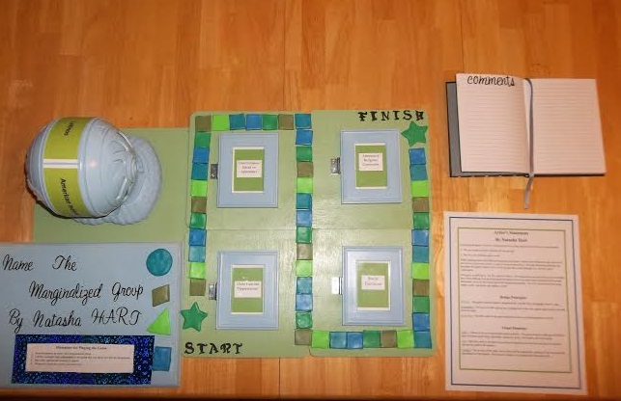

Artist’s Statement
By Natasha Hart
In playing the game Name the Marginalized Group, the player is to come to two conclusions:
1. The only correct answer includes all four groups.
2. This is a very difficult game to win.
When studying about the different marginalized groups I came to the realization that many have had similar experiences when it came to being marginalized. Through interacting and playing this game the player realizes ALL of the groups have gone through ALL of these same experiences.
This game is difficult to win for a specific reason. The experiences the groups have gone through have been difficult. Just as in the game the player is to move three steps forward and two steps backwards, so is the life of person of the marginalized group. For every step forward the group makes, some regression can happen as well.

Design Principles
Balance- The game board is balance symmetrically with the four rectangular doors to open.
Opposition- The curves of the spinner are in opposition to the very square game board, tiles and doors to open.
Repetition- The tiles used on the game board are done in a repeating pattern of colors.

Visual Elements
Color- I chose to use two main colors-green and blue. The game board is made up of different hues of theses colors-blue, light blue, turquoise, green, olive green, and neon green.
Line- The lines used in the piece were mostly straight lines in the tiles and doors with some curved line used in the spinner.
Texture- The texture of the piece can be felt with the raised tiles, opening of the doors and the smoothness of the spinner. This piece is meant to be touched and interacted with.

Creative Process

I started making the game board by gluing some square unfinished wooden frames to a board.
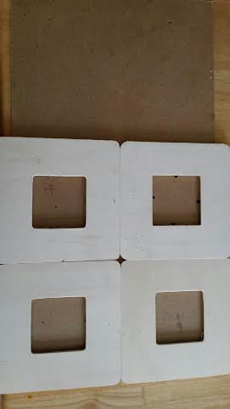

Next I spray painted the whole thing green and used stencils to make the “start” and “finish” on the board.

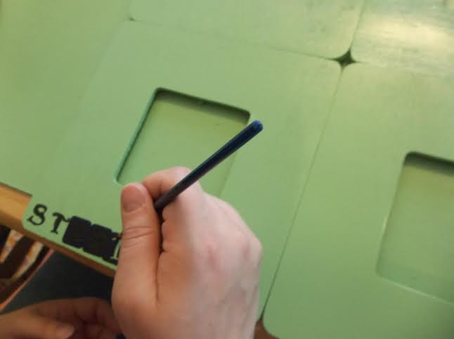

After that I started the tedious process of cutting out the clay tiles for the game board.
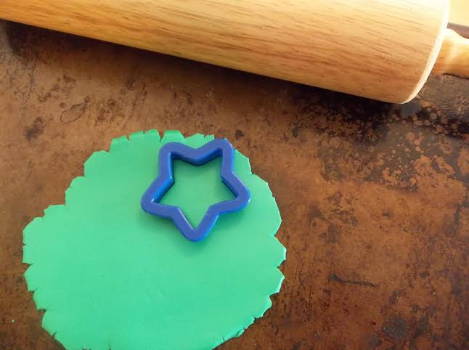
These are the playing pieces.
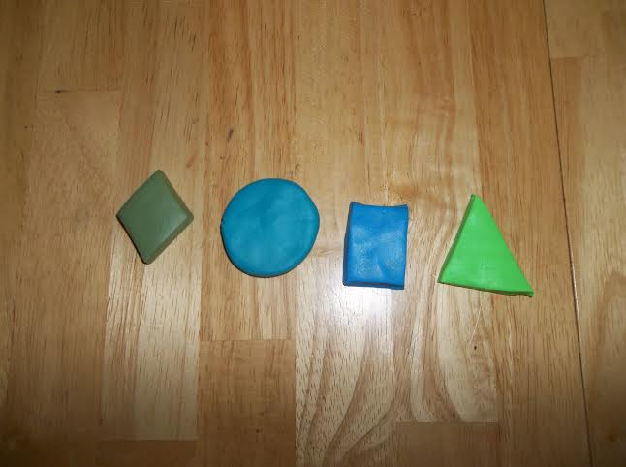
The clay I used was an oven bake clay so the tiles had to be baked.

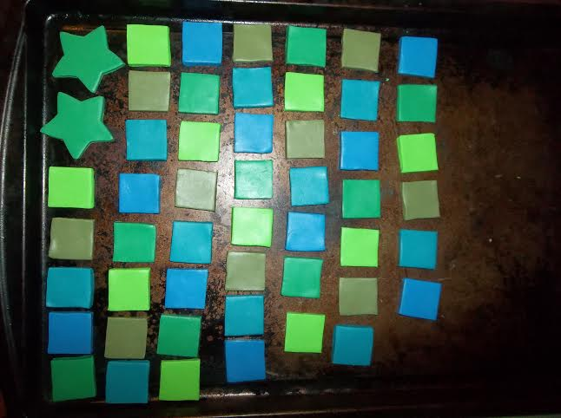
Then I placed the tiles in a repeating pattern and glued them on. This took quite a bit of rearranging before I got it to the way I liked.
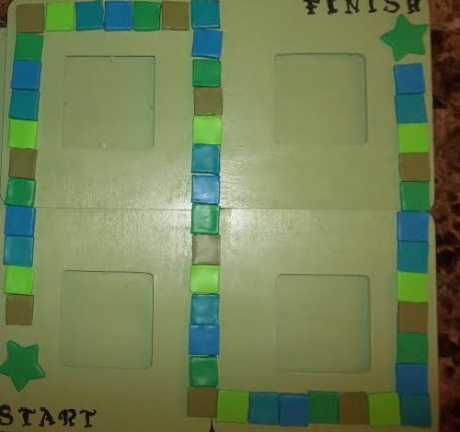
The spinner for the game is a repurposed old toy that I spray painted blue. 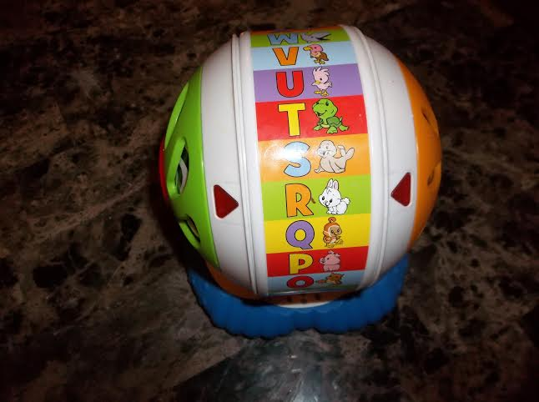
I also spray painted a wooden plaque that would display the title of the game with my name and the directions for play. These had to be glued to the board and then I used letter stickers for the words.
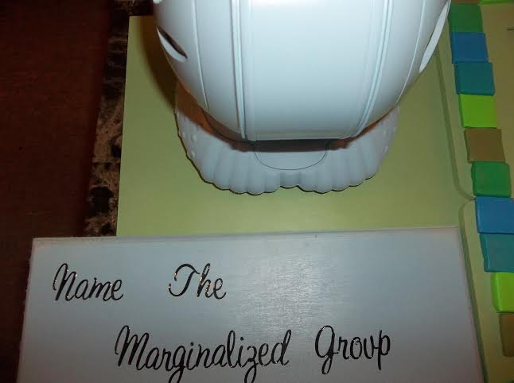
I printed out the experiences of the marginalized groups to go in the doors (which are small frames).
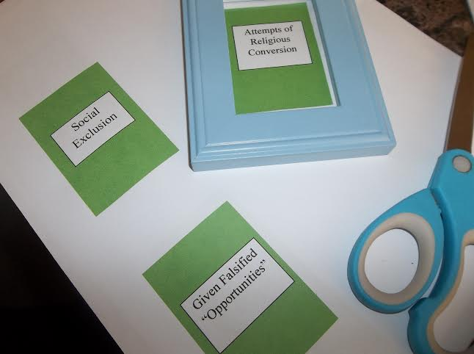
I installed hinges on the doors to make them open. Small feet had to be put on the backs so they would lay correctly as well.
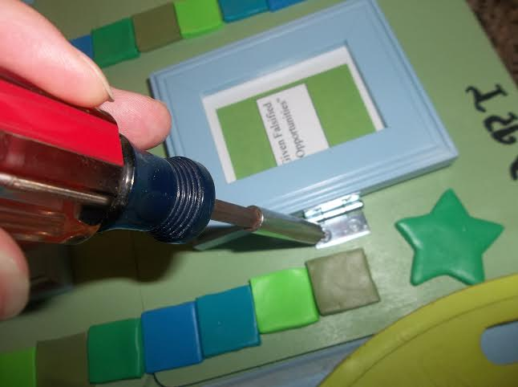
I glued the directions on the back of the doors explaining how to move on the board if the player answered correctly.
.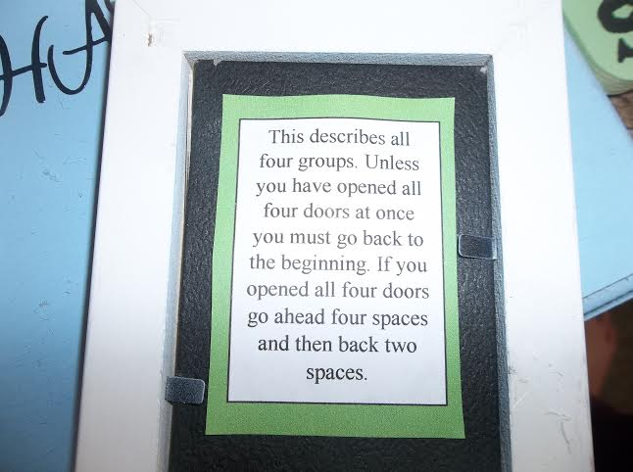
I glued the names of the groups and the arrow on the spinner.
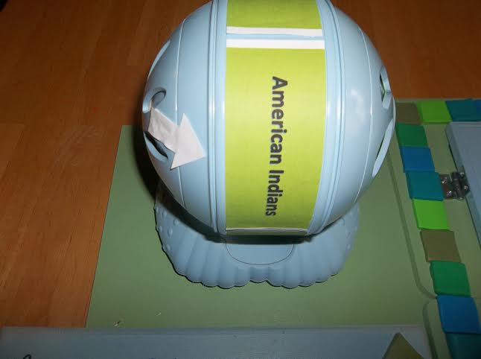
I glued the directions for play on the plaque. The directions are as follows:
Directions for Playing the Game
- Spin the spinner to arrive on a marginalized group.
- Lift the rectangle that corresponds to the group that you think best fits the description.
- Move the appropriate amount of spaces.
- When you reach the Finish, you have won.
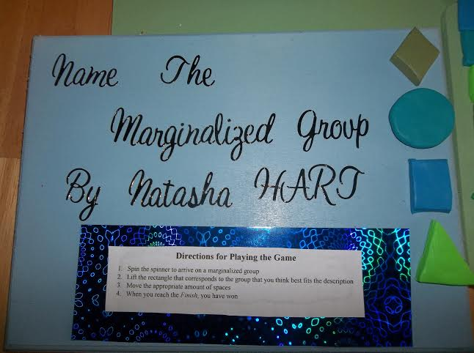
Here is the finished piece. Thanks for viewing my sculpture!