Erin Piel

LESSON PLAN – What does a family look like?
Time: About 1 hour period
Grade: 8th grade
Objective:
Students will engage in a civil conversation that shows respect to their classmates’ and differing opinions.
Students will understand that even if their opinions are different, they can be accepting of those that are different.
Vocabulary:
Family - a group of persons who form a household
Traditional Family - two parents (male and female) and their biological children
Modern Family – any family that is not “traditional”
Parent - a person who guards, protects, or preserves
Snappy Launch:
1. Show students the image below. Ask them to draw the car decal that would be posted on the back of their family’s car. (Provide students with the definition of “family” to ensure the inclusion of students that have non-traditional families.)
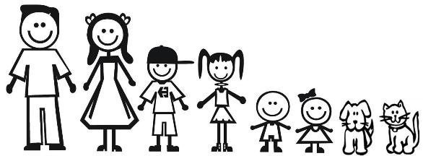
2. After providing students with enough time to draw their family, call on students to volunteer and share their family decals.
3. Ask students, “What makes a family a family?”
- track students’ response rates (see rubric below)
- list the variety of explanations and key words on the board
4. Review the class’ idea of a family; note how we have varying concept of “family”
Activity/Discussion:
1. Explain that today we are going to be looking at a “Modern Family” (quite a few students will think of the TV show).
- A modern family is becoming more common that the “traditional family”
2. Ask to all stand and move around the classroom to the sign (agree, strongly agree, undecided, disagree, strongly disagree) based on their opinion of the following statements. (Students will be scored on the number of comments they make [+3 minimum] and the respect they show their classmates.) It is critical for the teachers to monitor the discussion for respect.
- The best type of family is a traditional family.
- Modern families are just as good as traditional families.
- Loving and caring parents are what make a good family.
- Children raised by a single parent are worse off than a child raised by two parents.
- Gay parents are just as good at parenting as mom/dad parents.
- Family structures are changing and that is okay.
3. After all students have participated in the discussion, have students return to their seats. Remind students of how they responded to the question “Loving and caring parents are what make a good family.” Tie this into the fact that regardless of the family structure (gay parents, single parents, grandparents), loving and caring for children is what is really important.
4. End the lesson by showing students the video clip of the actors of "Modern Family" - the following day's lesson may include a starter discussion based on this clip.
*Note: This lesson can lead to a very heated and uncomfortable discussion if not carefully monitored. In my 8th grade social studies classes, we spend a considerable amount of time emphasizing the importance of RESPECTFUL discussions. I want all students opinions to be heard—agreement cannot always be accomplished, but acceptance can.
Assessment:

