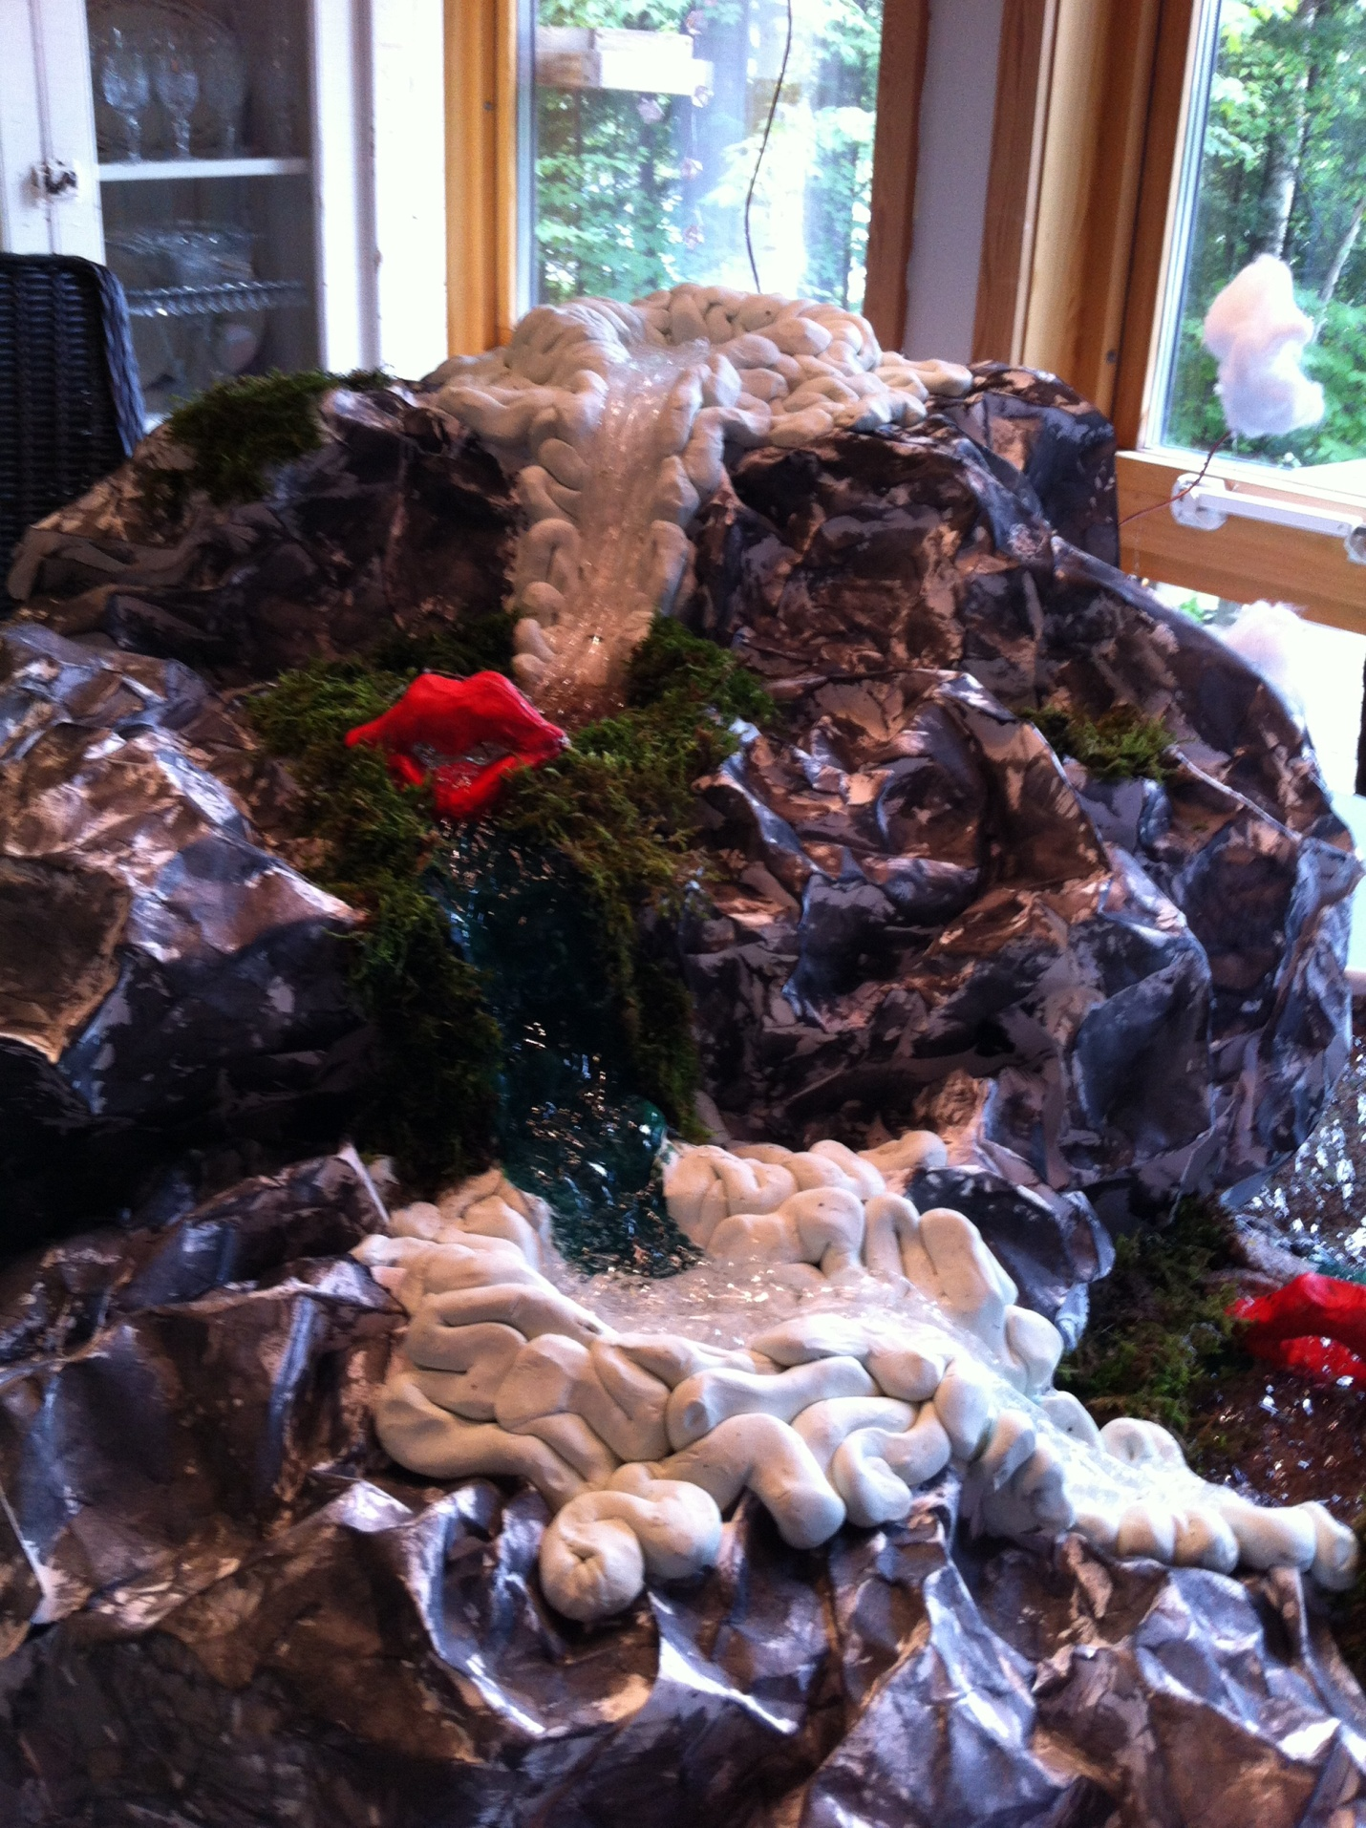

Spill What You’re Filled With
Valerie Sandstrom
Human Relations in Education
Dr. Barbara Bridges
Sculpture
Summer 2015
Artist’s Statement
There is data all around us, ready to be collected. As educators, it’s our job to collect all data, all the time; to not just collect what we assume is correct, but to dig beneath the surface. Why? Because our data intake doesn’t stop in our own brains, it flows out of our mouths and into our students’ brains. It becomes the data our students collect. And this data flows from our students’ mouths to those around them. As they move beyond the classroom and into the world, they take their voices with them. These voices shape public opinion, and ultimately, the data which is available for collection. It’s a cycle which can’t be stopped.
It’s like the water cycle in a waterfall. The data is in the clouds, and rains down to be collected in the first pool of water, our brains. From our brains, the water flows into the next tier, our mouths. It continues down the next two tiers, the students’ brain and mouth, until it lands in a large pool at the bottom, the world. Water from the large pool (the data which our students have put into the world) is evaporated and becomes the data in the rainclouds, ready to fall once again.
Creative Process
This idea came about through the overall structure of this class. For each unit, we took in data and wrote a lesson plan using what we learned through the information. Each lesson plan was written with the purpose of affecting the students who heard it, which would, in a larger sense, affect the world. I began thinking of this process as a cycle, and through discussion with my family, it morphed into the idea of a water cycle.
For the construction side of it, I consulted an artistic friend of mine regarding the materials and process.
The process went something like this…
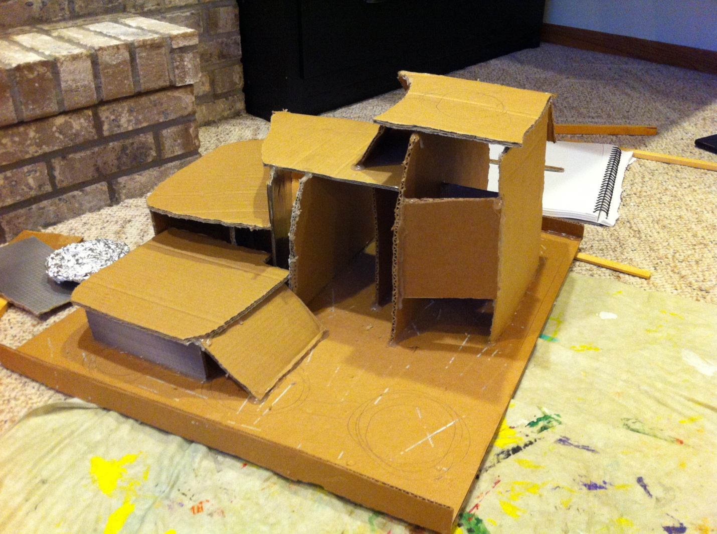
First, cardboard box pieces were cut and shaped to form the base of the waterfall and glued together using hot glue.

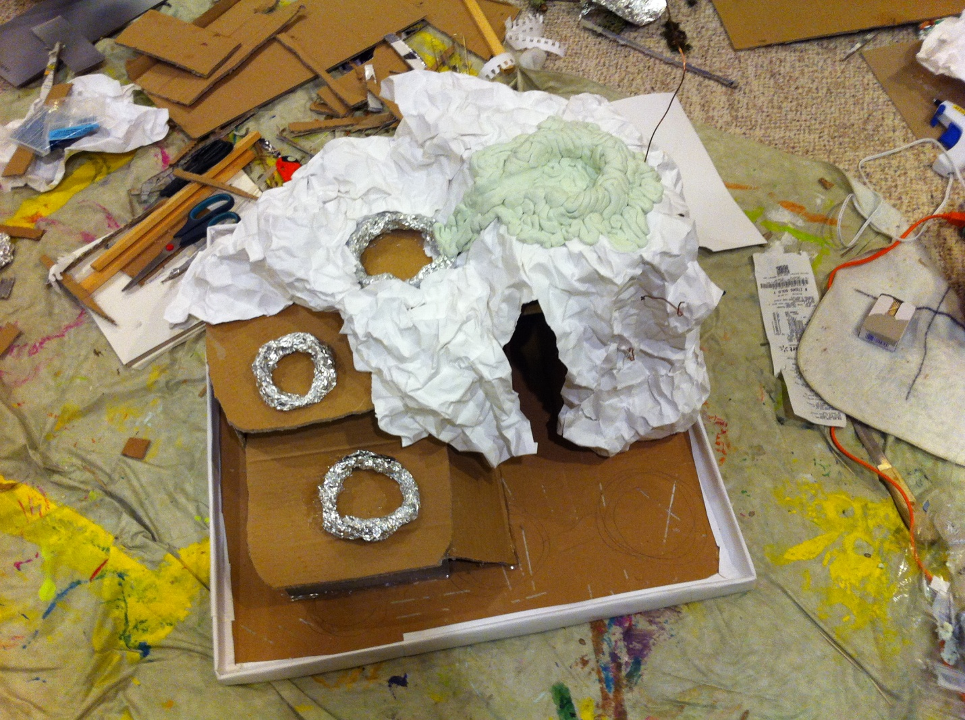

Next, watercolor paper was crinkled and glued to cover the cardboard base and to form the rock surrounding the waterfall. Tinfoil rings were placed on each layer of the waterfall and the clay was formed into brains and placed on the two brain layers.

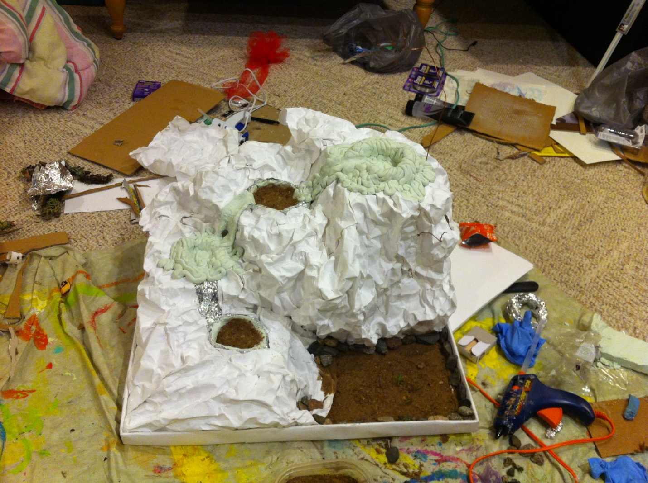
Sand was glued in the two remaining “lip” pools and at the bottom of the sculpture where the “lake” would be. Rocks were then glued around the lake.
The clay lips were formed and moss was placed around the perimeter of the pools.
Then came the painting. The lips were painted red, the falls were painted blue, and the “rock cliff” was painted gray and black.
The “data cloud” was made out of another sheet of crinkled paper with small pieces of newspaper glued to it to represent data from the world. Crystal beads were strung through fishing line and connected to the cloud to serve as the raindrops of information falling down onto the brain. The cloud was attached to the top of the mountain with copper wire.
And finally, hair gel was squirted into the waterfall/ pool areas and the lake at the bottom to look like the water flowing through the data cycle.

Design Elements and Principles
Color: Grays, browns and blue-greens represent nature, contrasted with the whitish colors of the brain and clouds and red of the lips
Texture: The smooth water and pools are contrasted with the jagged rocks and prickly moss
Form: Tiered, curved mountinous shape with cloud hanging overhead representing the descent of the information which falls from the sky
Emphasis: Cloud, brains, lips, and lake at the bottom vary in size, but are equally emphasized as the eye naturally follows the downward flow
Harmony: The pattern of the waterfall (brain, water, lips, brain, water, lips) makes for a balanced whole
Opposition: dark vs. light; water vs. rocky land

And the cycle begins….

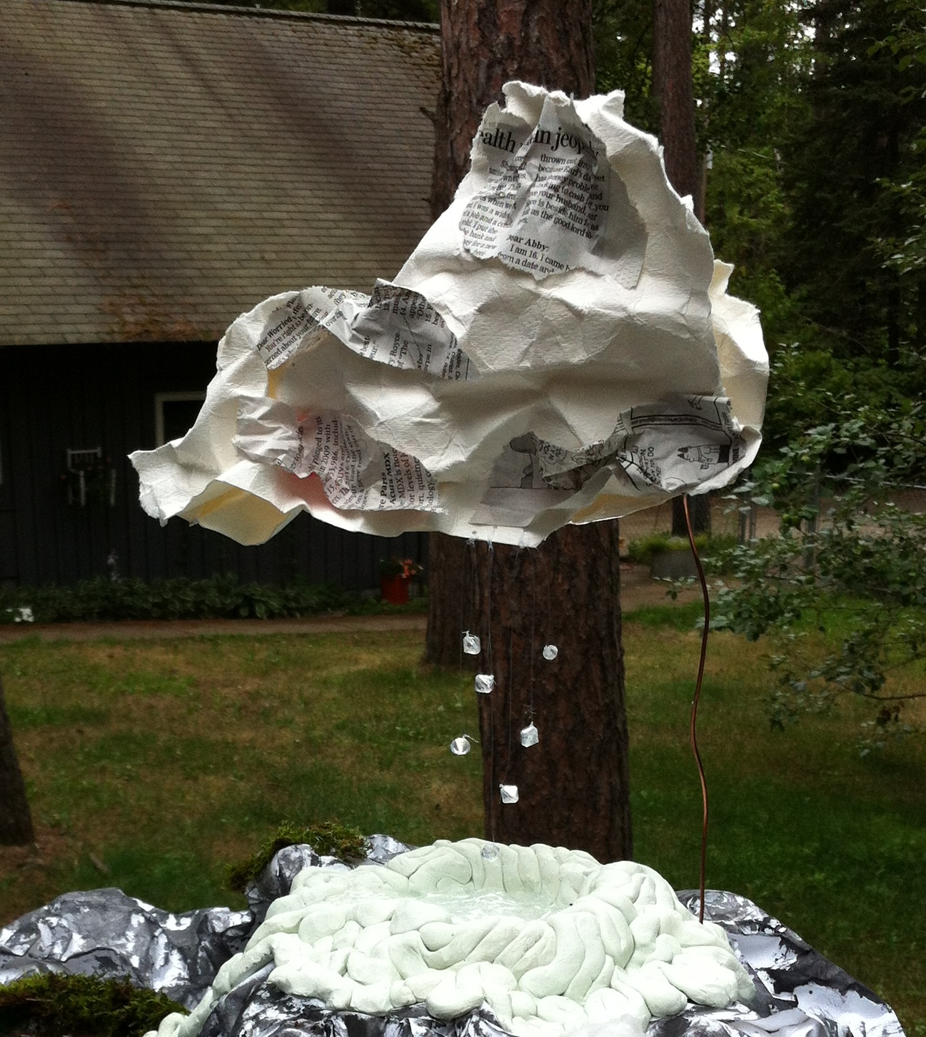
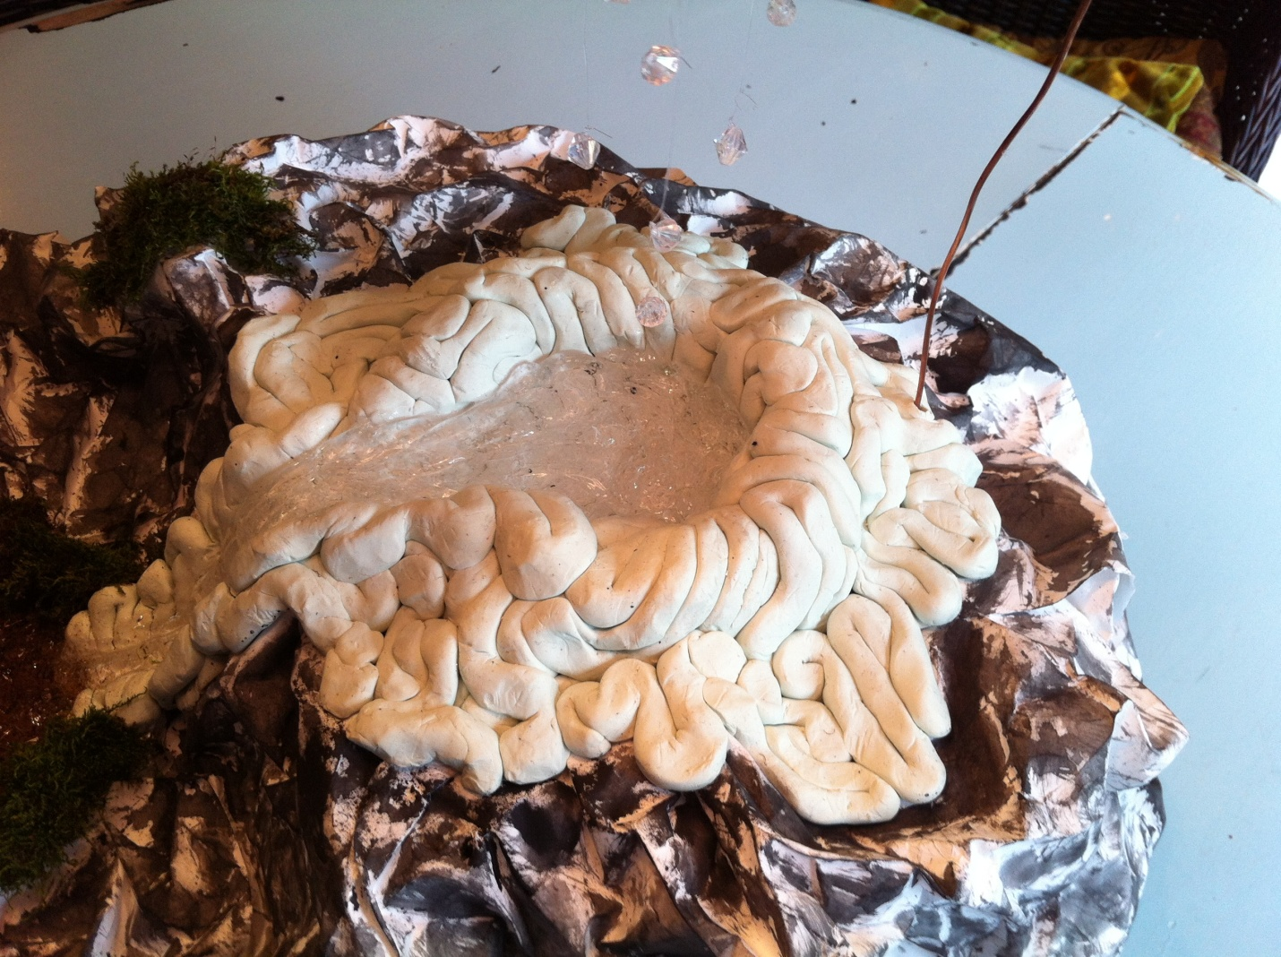
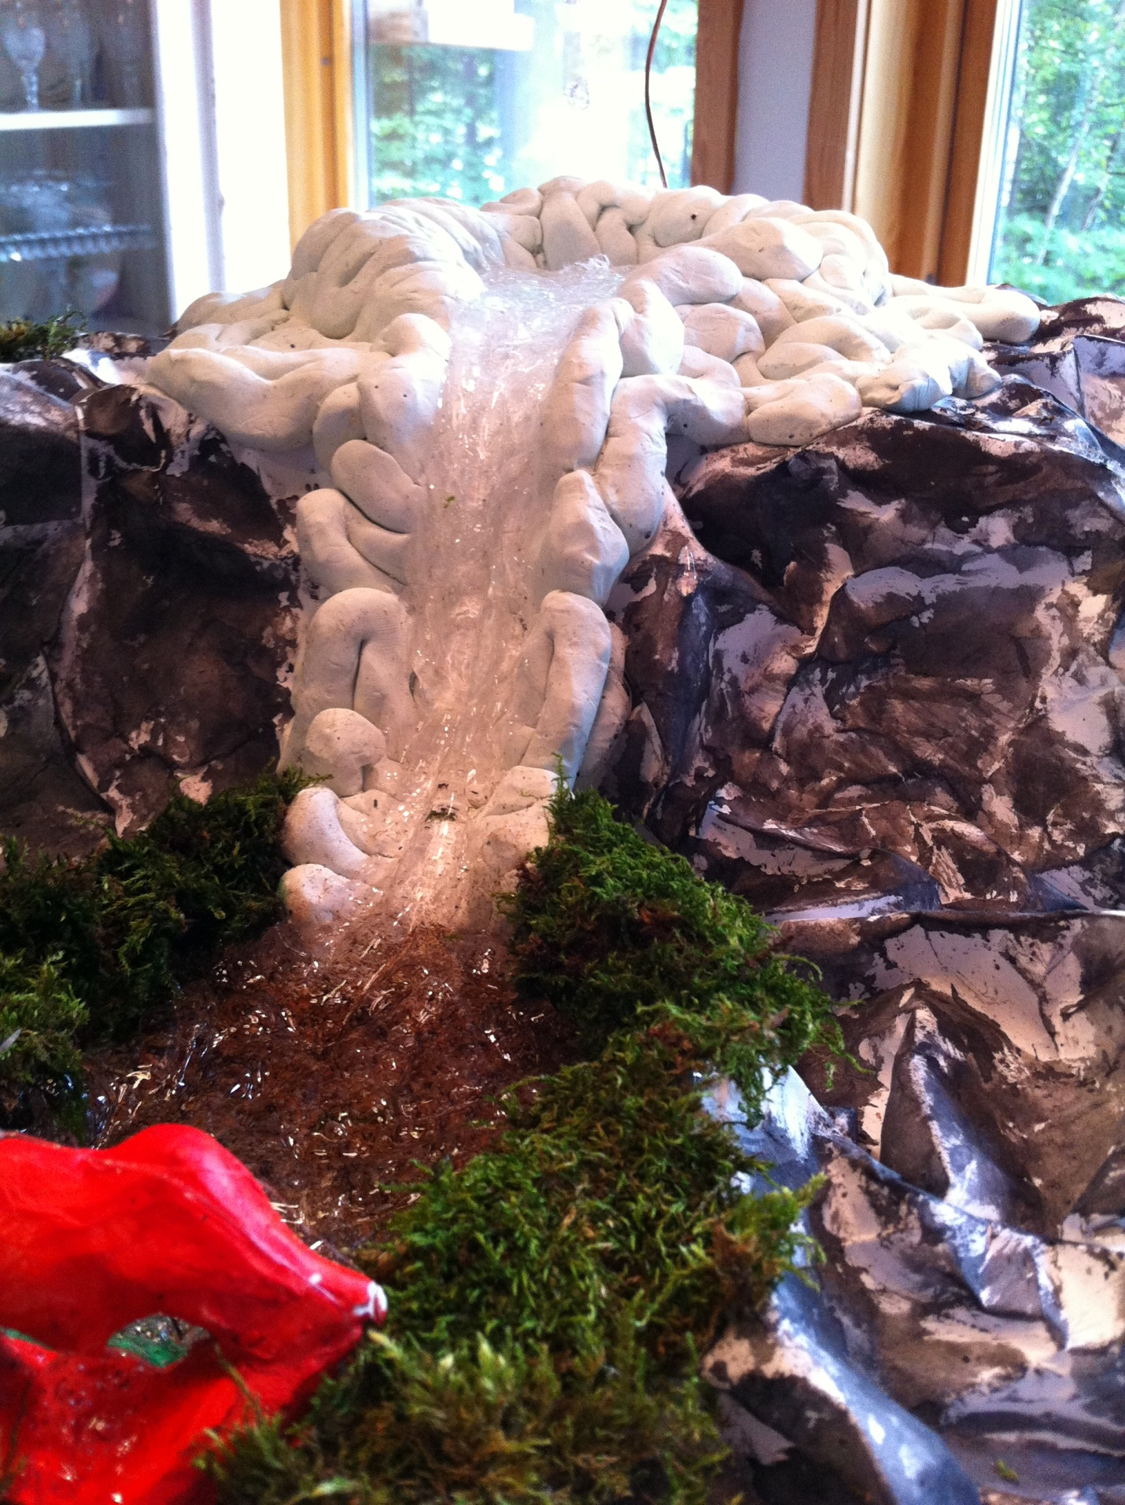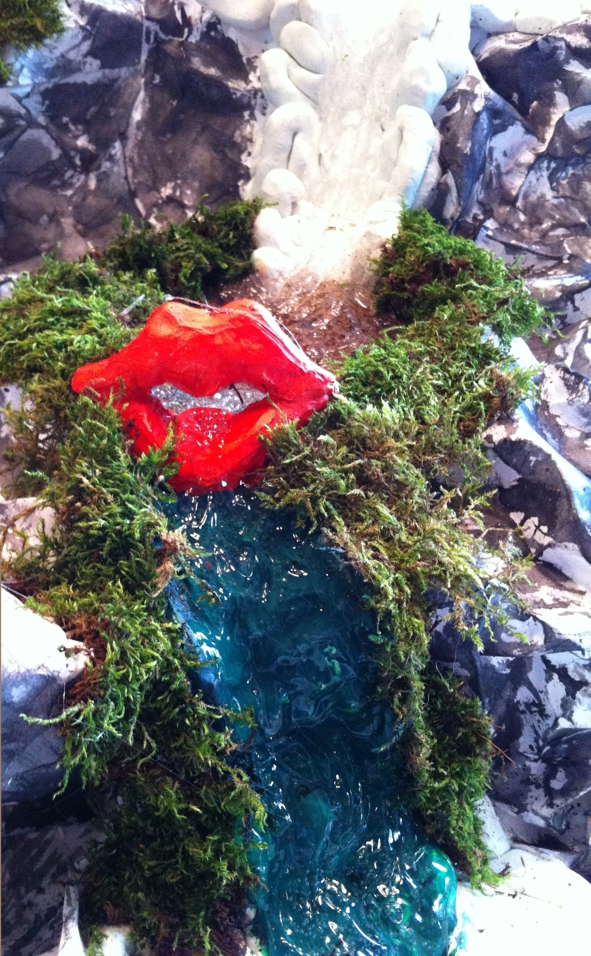

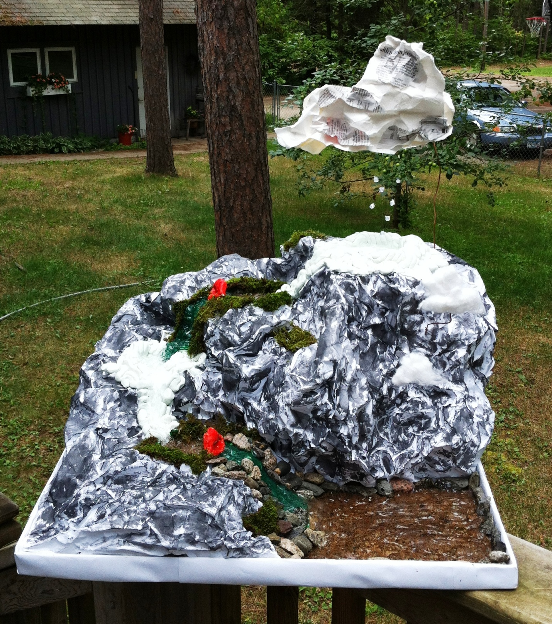

*My sculpture will be displayed at Howard Court, a business center in downtown Hibbing*

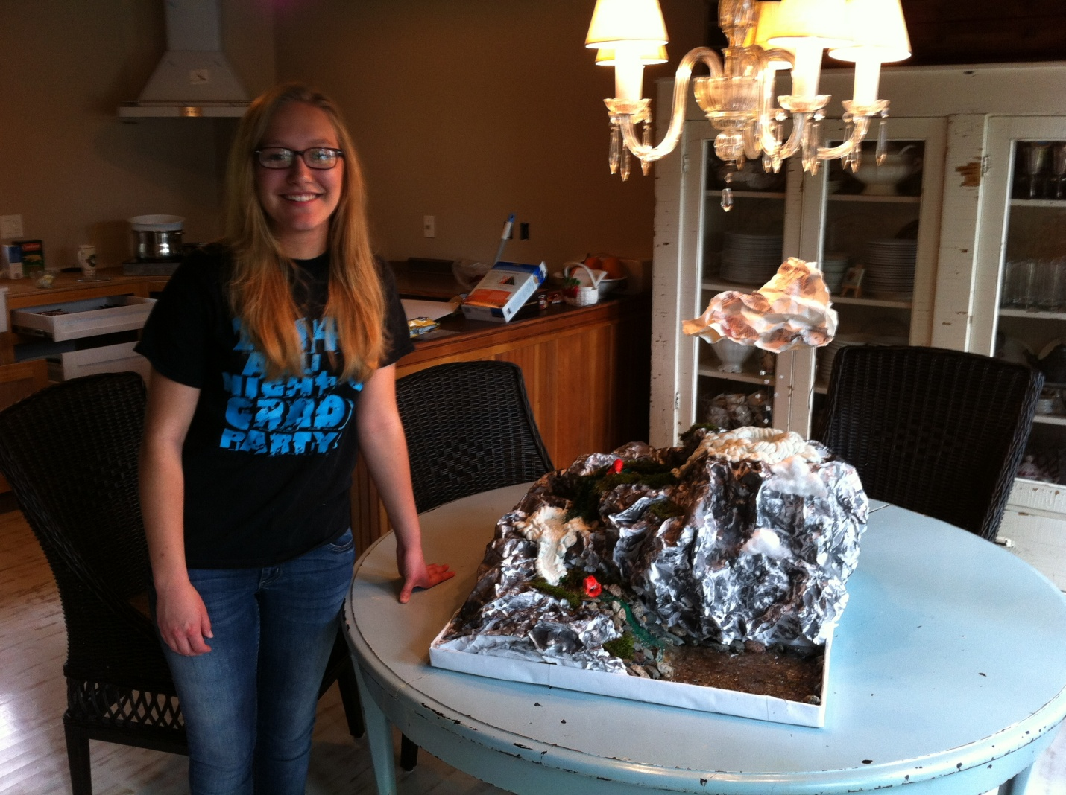

Comments Welcome Here!

