Erin Piel

Hands on, Hands off
Objective:
- Students will identify how they each learn best and explain the ideal learning environment.
- Students will share the challenges they face in the classroom.
- Students will work together to make a poster demonstrating the different types of learners – visual, tactile, and auditory.
Age Level: Grade 6
Duration: 60 minutes
Vocabulary:
- Learning Styles - (see graphic below)
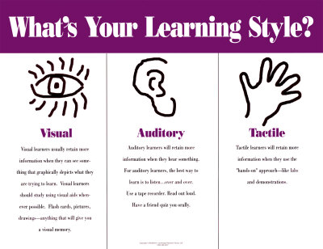
- Strengths - things that we feel we are able to do well
- Weaknesses - things that we can work on or improve
- Acceptance - recognizing something as adequate or suitable
Snappy Start:
- Show the following video clip from “Kindergarten Cop” https://www.youtube.com/watch?v=mce3yiMF4iQ
- Ask the students to share if they believe that is a good way to run a classroom? Ask them to explain why? What do they think a good “learning environment” looks like.
Lesson Activity:
1. Pass out a notecard to each student - tell them to not write their names on them
2. On the lined side, have them write down one of their strengths as a student (discuss what a strength is) *Give them time to really think about what their strength is.
3. On the other side, have them write down one of their weaknesses as as student (discuss what a weakness is) *Give them time to really think about what their weakness is.
4. Collect all of the cards and read a few of them to the class - both strengths and weaknesses (try to find a student that says they have a hard time sitting still or staying focused; if you can’t find one, pretend and say “I have a hard time sitting still all day”.
5. Discussion:
- Why all of the strengths and differences were different for each student. (Try to direct the conversation towards discussing how each student is different from one another.)
- Why does each student have a different strengths and weaknesses?.
- Do you think you guys would be good student in the Kindergarten Cop’s classroom?
- Do you think the Kindergarten Cop is very flexible?
6. Introduce the three different learning styles - visual, auditory, or tactile. Right the three learning styles on the board.
7. Have students think about how they might learn best; one a time, have students come up to the front of the room and write their name after the learning style that best suits them.
8. Explain how each all students learn differently - some like to sit and listen, some like to talk it out, and some like to get up and move! (This is where you can expand on we are all genetically inclined to learn a certain way; for example, students that are really fidgety in class might be more tactile learners.)
- Ask students how the Kindergarten Cop could help a student that is a tactile learner? Would he allow the student to stand up during a powerpoint instead of sitting?
- Emphasize how it is important to accept (define) our classmates learning styles.
Assessment:
Criteria | 4 | 3 | 2 | 1
Notecard Completion | Demonstrates reflection by completing both sides of the strengths/weaknesses notecard in detail | Demonstrates reflection by completing both sides of the strengths/weaknesses notecard, but one side is not detailed | Demonstrates reflection by completing one side of the the strengths/weaknesses notecard | Did not complete
Listening | Actively and respectfully listens to peers and teacher with no interruptions | Actively listens to peers and teacher with only one interruption | Listens to peers and teacher with a few interruption | Did not listen; many interruptions
Frequency of Participation | Contributes to discussion a minimum of 3 times | Contributes to discussion a minimum of 2 times | Contributes to discussion a minimum of 1 times | Does not participate

