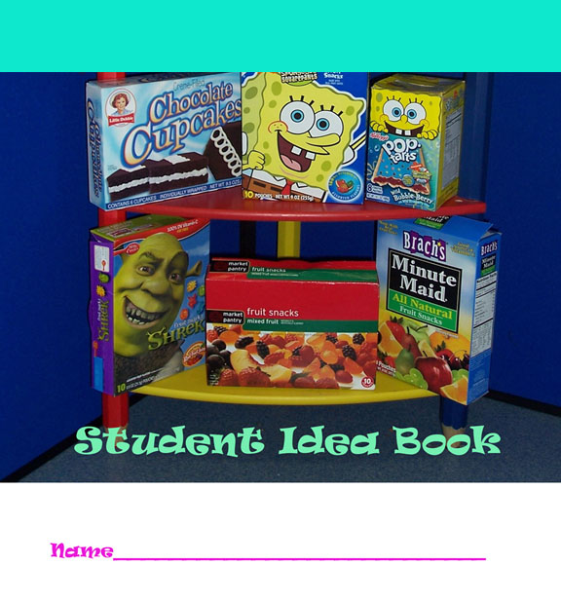

Name
Grade___________________________ School and Town____________________________

Send your FINISHED Idea Book (scan it as a jpg and turn it into a PDF) to drb@bridgescreate.com.

NAME THREE REASONS YOUR FAVORITE ICON IS EFFECTIVE.

COLLECTING AND ORGANIZING THE DATA

Legend:
* = sugar  0 = fat  D = Chemical dye  P = protein (meat, peanut butter, cheese)  = fruit | W = water  R = Red  B= Blue  Y = Yellow

RESEARCH
Name your product and explain why you chose this product.
INGREDIENTS
What ingredients are “bad” for your body?

What ingredients are “good” for your body?

Do the ingredients give you ideas for an icon? Include colors, materials and other details.

- Your IDEA # 1 (in words)

- Your IDEA # 2 A different one (in words)

Your student partner’s suggestions about your idea.

ICON DRAFT # 1 Just a quick sketch. No colors

ICON DRAFT #2 A more detailed sketch. No colors.

Write a paragraph explaining why your icon will become iconic.

How will you USE YOUR ICON TO market/advertise your product?

FINAL ICON DESIGN
IF YOU ARE MAKING A STOP MOTION OR ANIMATED ICON USING PIXALS.
GO TO THAT TOOL FOR THIS PAGE. PROVIDE THE URL OR THE FILE.
Make this in FULL color and label the characteristics to explain why you made these design decisions.

